**Circos Analysis on Pairwise Comparisons**

Description:

Circos Pipeline will take bed files and fai files generated from synteny analysis and generate Circos (<http://circos.ca>) images from pairwise comparisons. Here’s an example of an image generated:

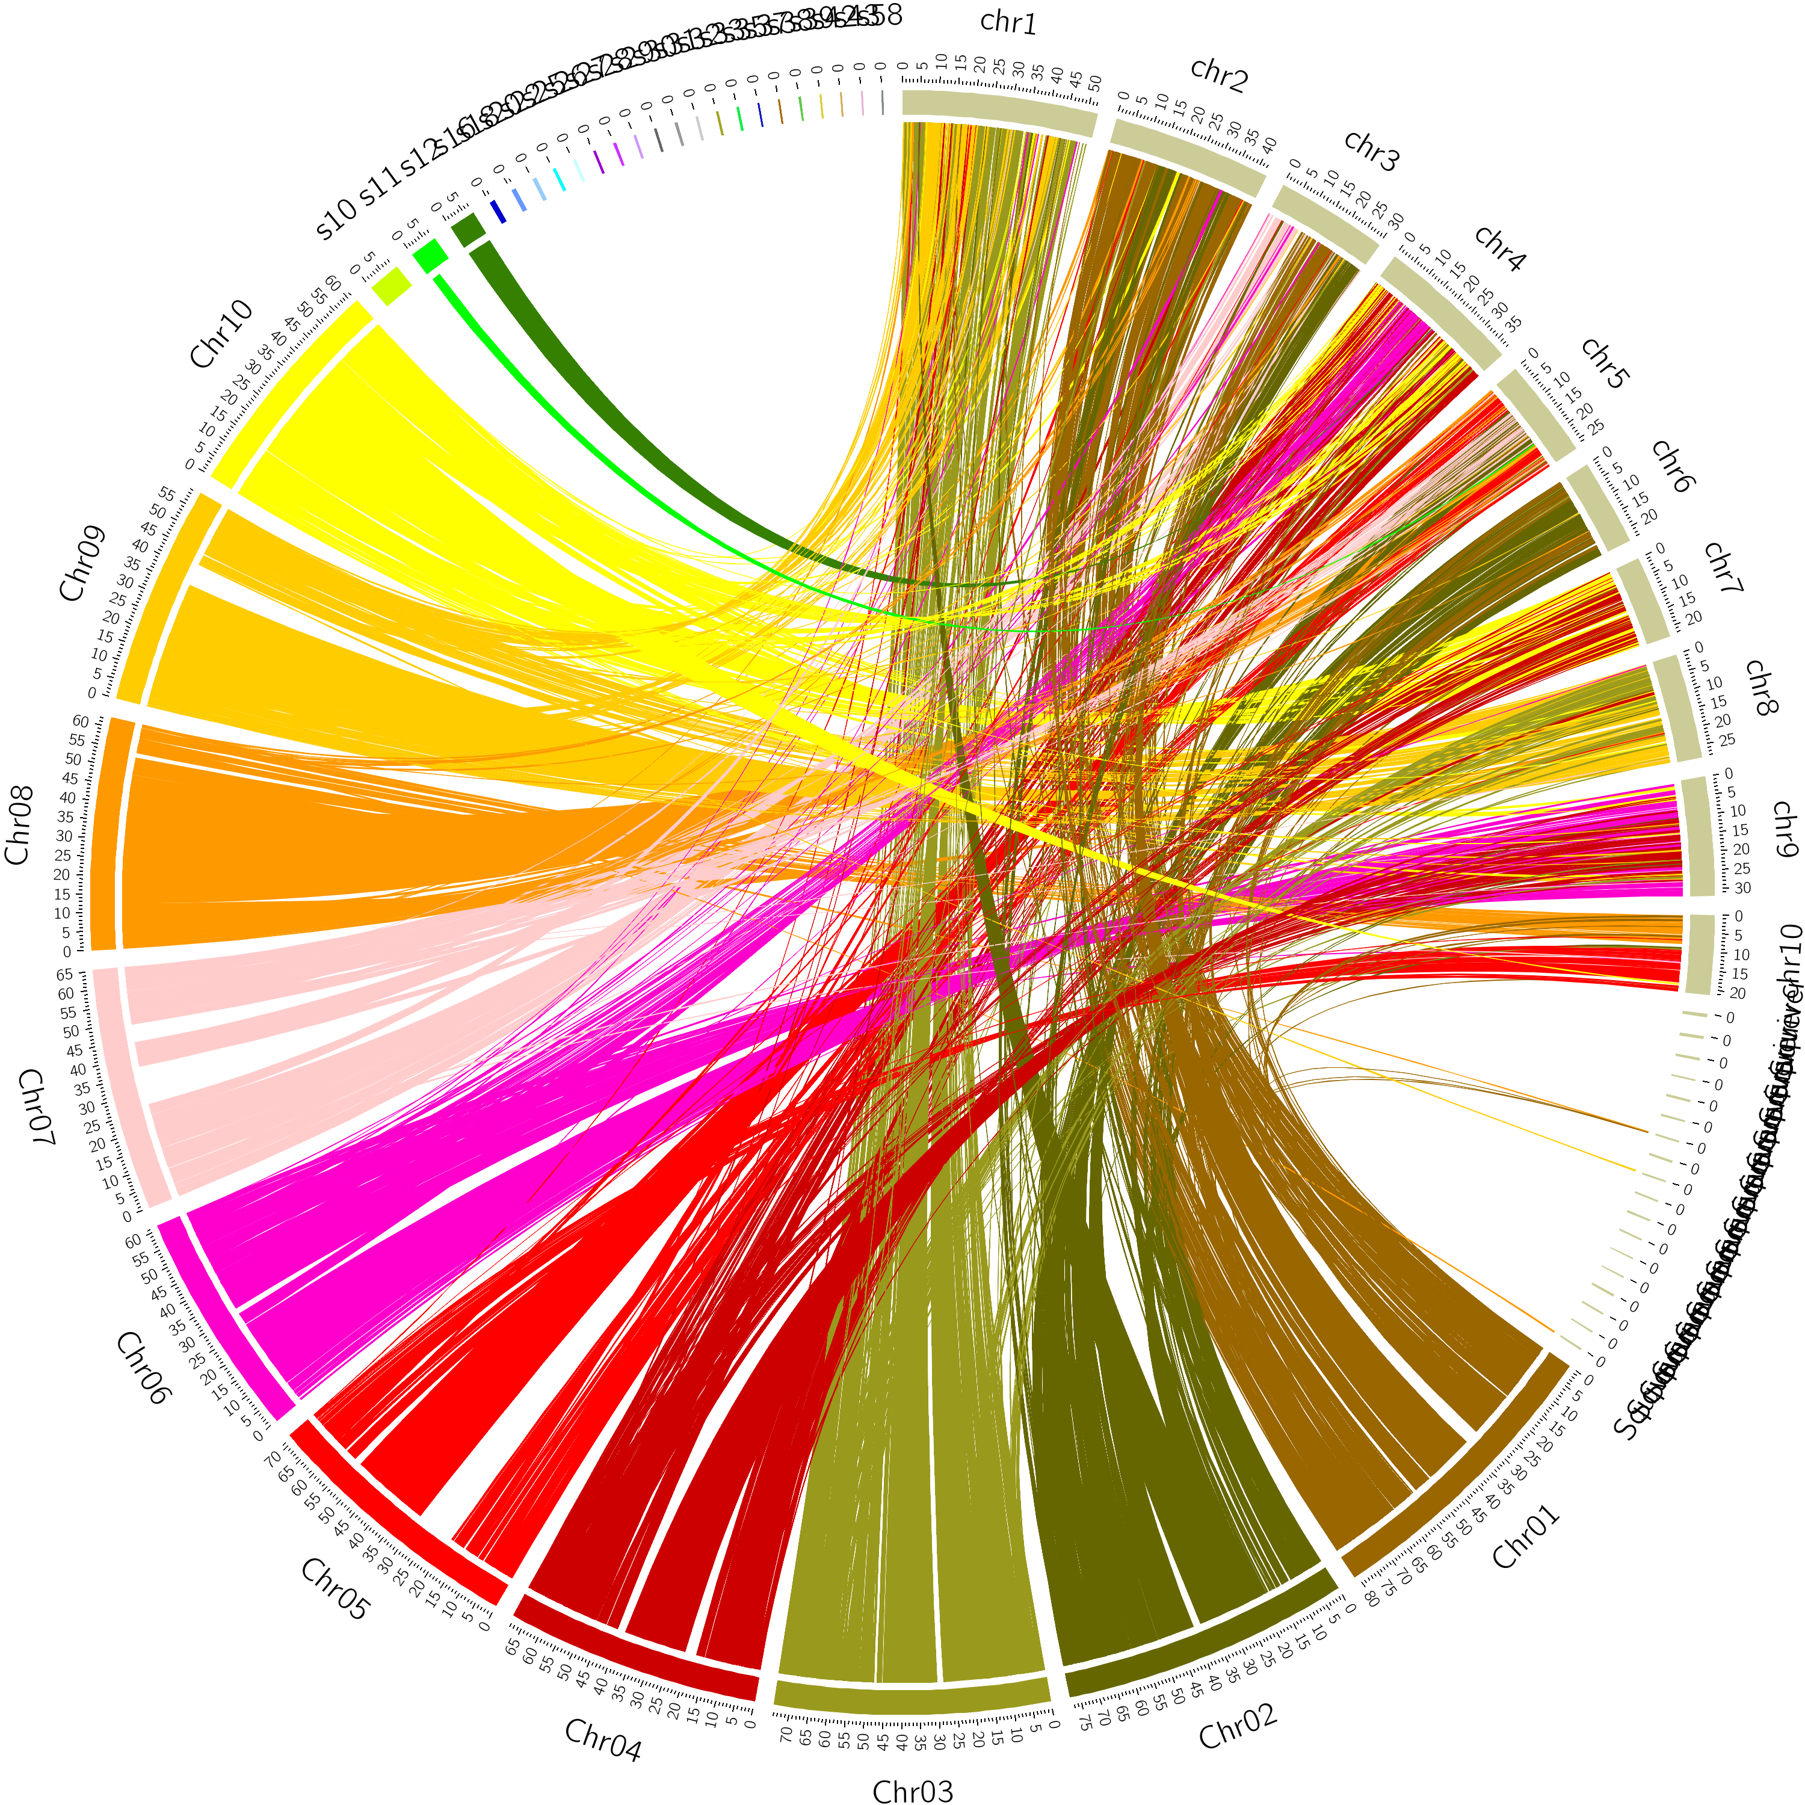

**Types Input Files Necessary:**

.bed- See Bedtools for more info on how it works. <http://bedtools.readthedocs.io/en/latest/>

pybedtools was used for analysis… Used for generating link files used to generate colorful bands seen above..

First three items on line describe query species, fourth describes target..

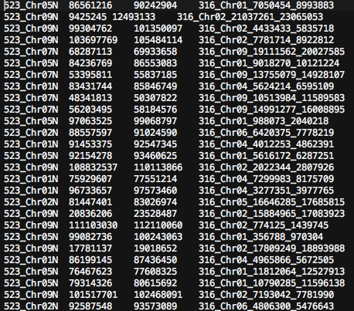

.fai- Not mentioned as output file from Synteny analysis, but these fai files are generated from running pyfaidx on genomes in synteny analysis. They are generated next to corresponding .fa or .fasta files. The .fai files describe “karyotype” .txt files and contain information about chromosomes and scaffolds. Format for line:

*Chromosome chr length start coordinate other unnecessary info*

(find pyfaidx online for more info)

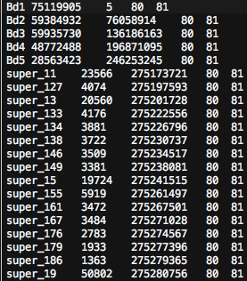

circosFiguresPipelineConfig.txt – Configuration file

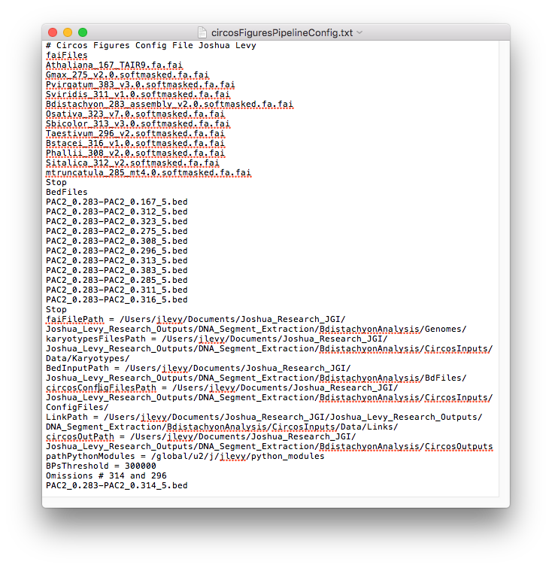

Specifies fai filenames, bed file names, file paths for: fai files, karyotype files, bed files, configuration files path to run Circos program, links files, circosOutPath for output images, path of Python virtual environment/ path of python modules installed.

Also included is a BPs threshold- minimum number of basepairs necessary to include a chromosome in the production of circos images.

.conf files- 2 Circos configuration files, txideogram.conf and txticks.conf help generate Circos images

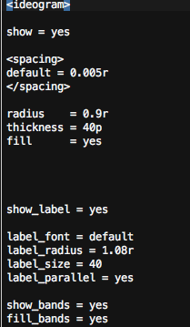 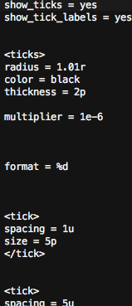

**Programs necessary to run analysis:**

* Circos- See documentation from <http://circos.ca> for installation help.
* Anything specified from Synteny Analysis.
* Four .py program files-
  + fai2karyotype.py
    - fai2karyotype imports list of faiFiles (convertFiles) and changes them to a list of KaryoteFiles and exports karyotype .txt filetypes corresponding to each species to the karyotype file path. For use with circos analysis.
  + generateConfigs.py
    - generates configuration files circos.conf and linksAndrules.conf for particular pairwise comparison, to be used to generate circos plot
  + circosFiguresPipeline.py
    - see main description above
  + bed2linkfile.py
    - bed2link inputs list of bed files, their input path, and output path for link file. Converts bed files to link.txt files to be used for circos analysis. Files are outputted to specified link out path

**Output Files**

Karyotype .txt files- generated from fai files using fai2karyotype. Similar format.

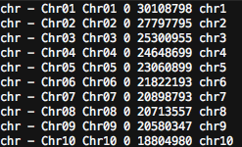

Chromosomes on left, how large each chromosome is (start end) in middle. Color (eg. chr4) on rightmost column. chr 4 corresponds to a color. There are special cases that may need to be considered when generating these files. Please email Joshua Levy for special cases. Do not perform analysis for *unassembled* wheat genome (and other special cases) for now... At least using the conversion program. These files will be accessed by Circos.

Link .txt files – generated from bed files. 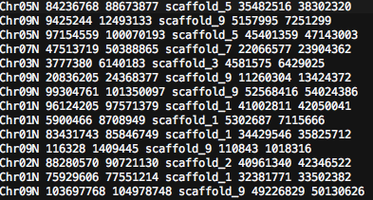

Each line contains pairwise syntenic segments between chromosomes of different species. These files will be accessed by Circos.

2 more circos config files .conf –

circos.conf-

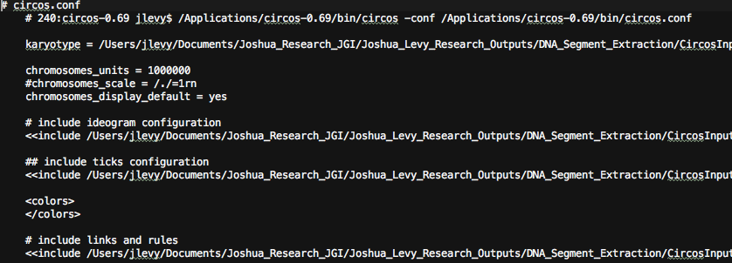

Synthesizes all configuration files and is main configuration file that Circos reads.

linkAndrules.conf-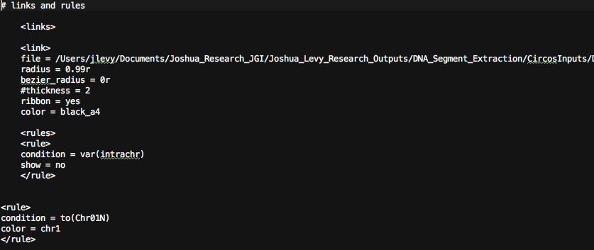

Specifies information about colorful bands/links above

The two conf files above will be generated anew for every pairwise comparison through generateconfigs.py.

Circos Output images .png .svg-

Images generated from each pairwise comparisons. Here’s another example:

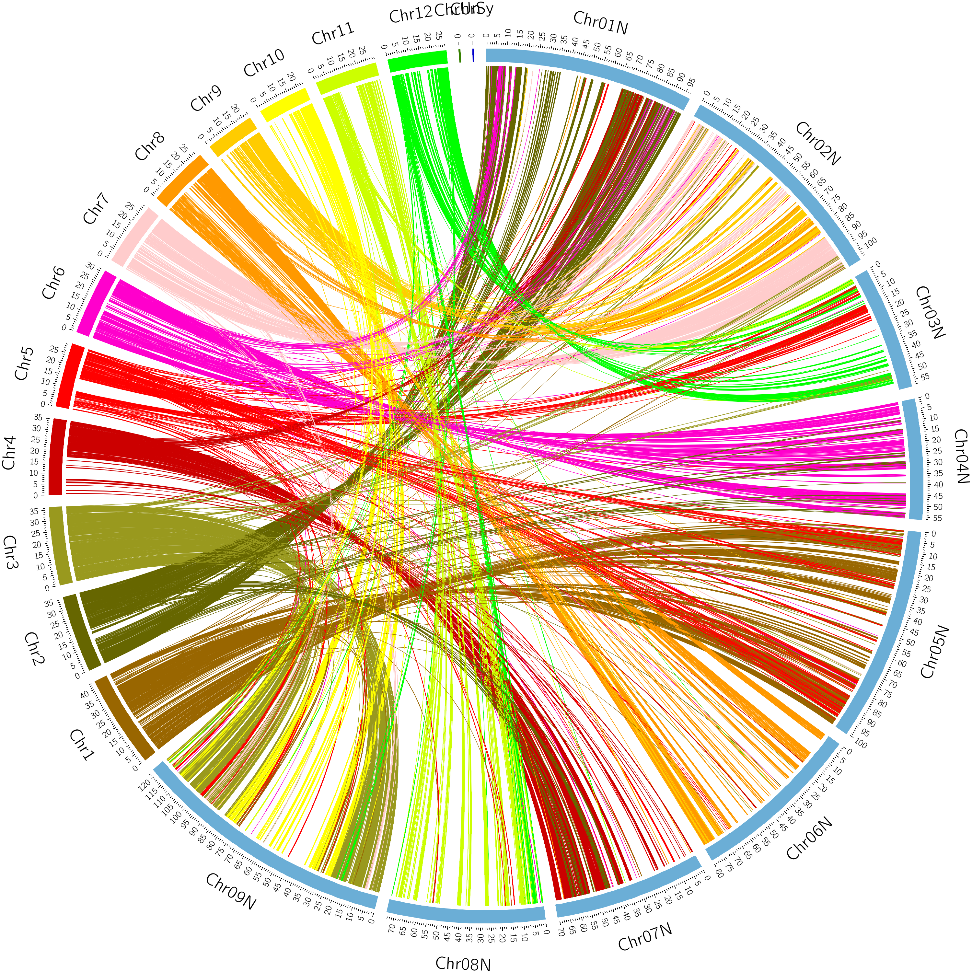

This is ultimately what we want to find. The filename reflects the pairwise analysis performed. Eg. 523-323.png

**Before we continue:**

Note: Only run this analysis on one query species at a time…

**Setting Up Analysis**

**Set Up Folder Structure and Adding Input Files**

1. Download folders from github repository (download analysis folder structure). This will contain all necessary input files. Can rename this folder for each analysis (one per query species; I happened to change mine to analysisDemo) and can move .py files (excluding gff to sort) to a higher directory. 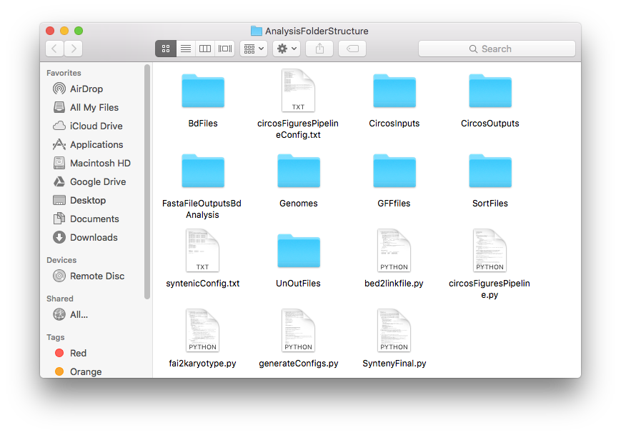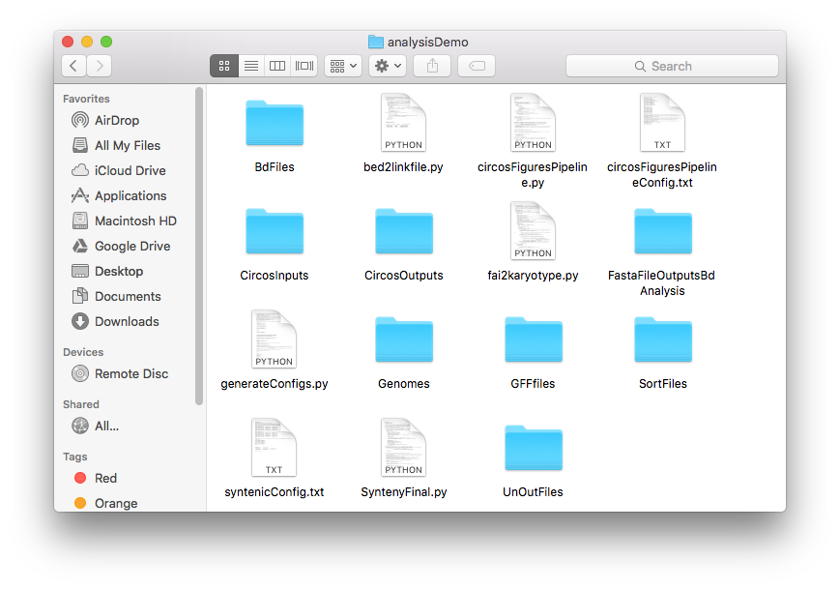
2. Perform Synteny Analysis to generate .bed and .fai files. .fai files should be in genomes folder (.fa files are not pictured here) and after running Synteny .bed files should be outputted to main directory folder (in this case analysisDemo).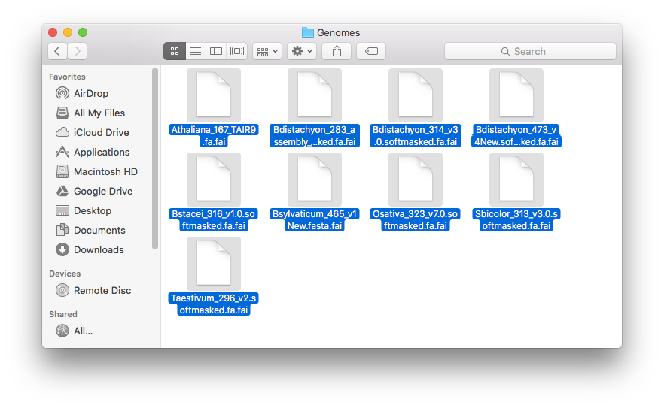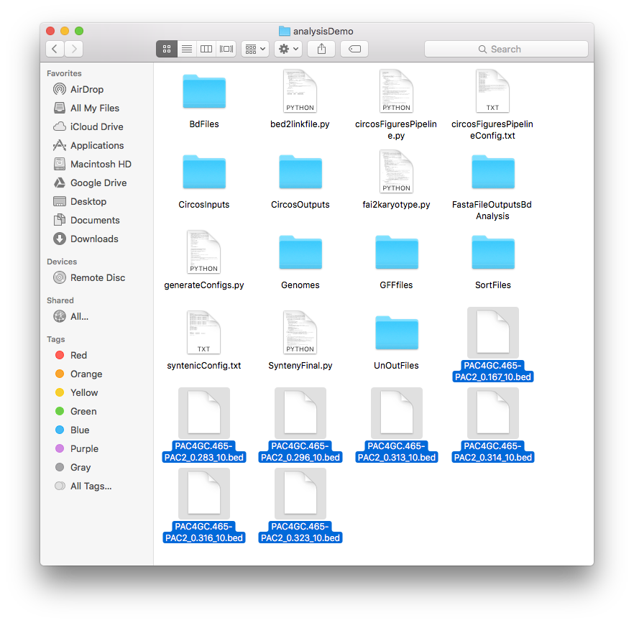
   1. Move the .bed files to folder BdFiles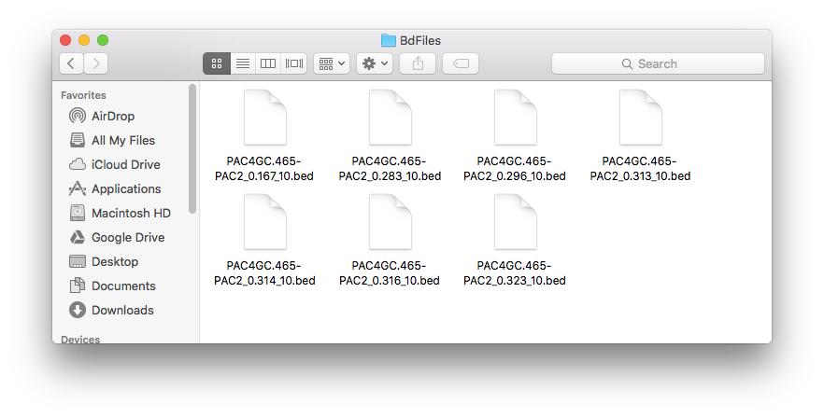
3. If you downloaded folders properly, everything should be set up. Please email Joshua Levy if problems.

**Setting Up Config File for the Pipeline**

circosFiguresPipelineConfig.txt

1. Open file listed above in the analysisDemo and edit.
2. Erase info from the highlighted fields: 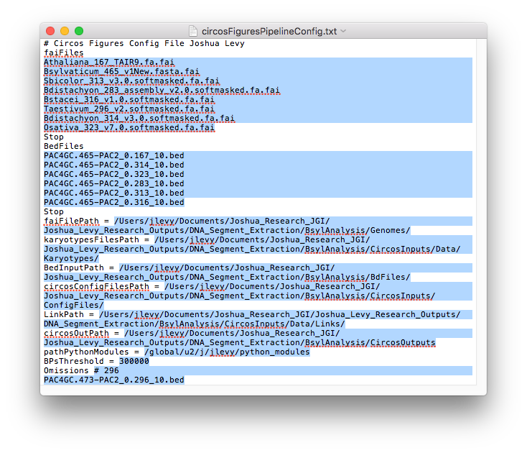 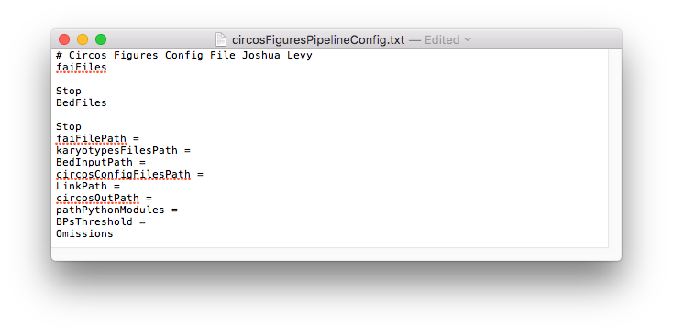
3. Add your own info (names of fai files, Bed Files, the path of the fai Files, path of karyotype files, bed files, circos conf files path, link path, circos images path, path of python modules, basepair threshold)
   1. NOTE: Do not edit any of the field names nor the corresponding syntax.
      1. Also, copy the entire full path of files.
      2. Include “/” at end of every path name
   2. Where to find the locations of each file path within analysisDemo (full path to analysisDemo is ‘..’):
      1. faiFilePath: in folder ../Genomes/
      2. karyotypesFilesPath: folder ../CircosInputs/Data/Karyotypes/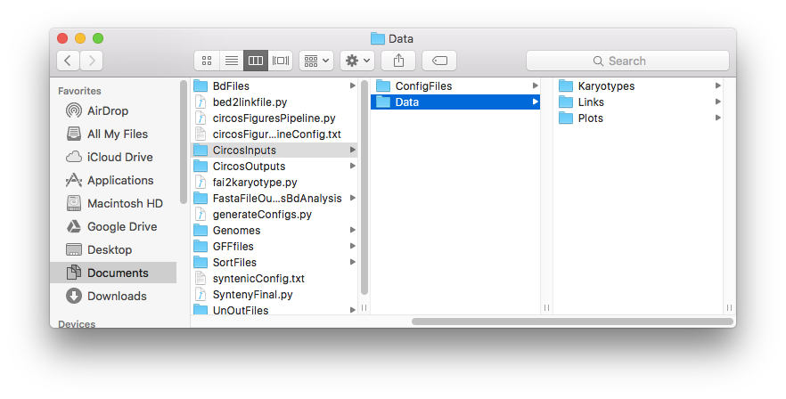
      3. BedInputPath: ../BdFiles/
      4. circosConfigFilesPath: ../CircosInputs/ConfigFiles/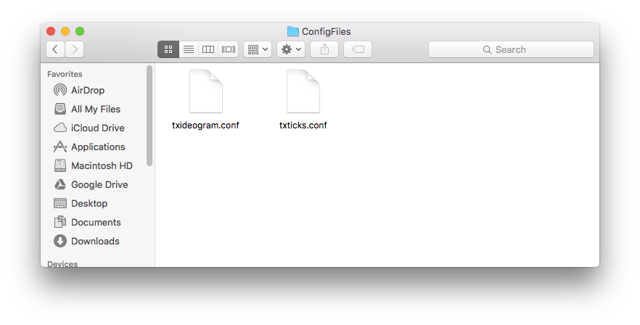
      5. LinkPath: ../CircosInputs/Data/Links/
      6. circosOutPath : ../CircosOutputs/
      7. pathPythonModules: (your own specification, especially running in virtual reality environment; could leave as is and will not make a difference)
   3. BPsThreshold- default is 300000

**Naming Conventions**

Name bed files like “PAC4GC.465-PAC2_0.323_10.bed” should be similar to unout naming from Synteny Analysis.

Name fai files like the following:

Sbicolor_313_v3.0.softmasked.fa.fai

Bdistachyon_283_assembly_v2.0.softmasked.fa.fai

The two underscores delimiting the species name (eg. 313 and 283) is essential. Format should be like xxxx_313_xxxx.fai . There should be no underscores before _313_ …

**Running Analysis**

Run on the command line or in an IDE calling python circosFiguresPipeline.py, which will run all of the analysis scripts.

Change the directory to the analysisDemo (or your analysis) folder.

Check CircosOutputs for images. Please let Joshua Levy know if running into difficulties.

*Enjoy!*

*-Joshua Levy joshualevy44@yahoo.com*